EASTER ISLAND - RAPA NUI. NEW BOOK ! By Corinne RAYBAUD
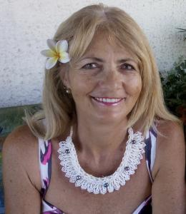
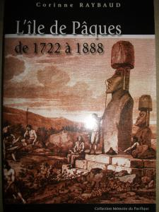
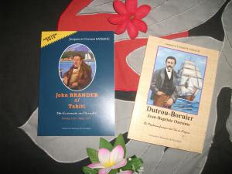
TAHITI, FRENCH POLYNESIA, November 7, 2017 /EINPresswire.com/ -- EASTER ISLAND - RAPA NUI. NEW BOOK ! By Corinne RAYBAUD
Corinne Raybaud, Doctor of History at the University Paris X Nanterre and Doctor of law at the University Montesquieu Bordeaux IV has focused her research activities on the history of Tahiti, Easter island and the islands of the Eastern Pacific ocean. Her specialities are Easter island between 1862 and 1888 and the development of the law in Eastern Polynesia from 1767 to 1945. Corinne Raybaud lives in Tahiti.
Her first book, published in 1996, is dedicated to Easter Island. Since 2008, she wrote books based on her universitary works on Easter Island and polynesian laws.
Corinne Raybaud writes about the history of Easter island : from the arrival of the Dutch navigator Jacob Roggeveen in 1722 to the annexation of the island by Chile in 1888. During this period, the islanders of Easter island -named Rapa Nui- had to deal with the first Europeans, Peruvian raiders, then the evangelization by French catholic missionaries, colonization by a French captain named Dutrou Bornier and finally with the annexation by Chile in 1888. For a few years, French Captain Dutrou Bornier exploited the island with the help of his Scottish friend John Brander.
The author relates the history of the Rapa Nui population and the interactions with foreigners : Peruvian, French and Chilean. Easter island, located in the South Pacific ocean, is the southeasternmost point of the Polynesian Triangle in Oceania. Easter island is famous for its monumental statues called moai. UNESCO made of Easter island/Rapa Nui a world heritage site.
Corinne Raybaud wrote 3 books about this period : L'île de Pâques de 1722 à 1888, John Brander of Tahiti, un Ecossais au paradis and Dutrou Bornier, le Capitaine français de l'île de Pâques.
These books are on sale in book stores in Tahiti and on Amazon Kindle.
More information on our website :
www.memoiredupacifique.com
facebook Mémoire du Pacifique
Corinne Raybaud
Corinne RAYBAUD
Mémoire du Pacifique
+68987323318
email us here
Share on Facebook · Twitter · LinkedIn · Google+

